
Yes, it’s “happening here”, but we want to make sure that whilst it is you are able to do things as normally as possible. And with a small amount of planning and good information you should be able to avoid too much disruption to your lives…..

WFHA’s day-to-day work and visits
The office will be open normal hours for the whole period. If our staff encounter difficulties getting to their normal place of work we have contingency plans in place to allow people to work at different locations.
During busy traffic periods it may not be possible for staff to visit all our schemes as regularly as normal. It may be that Scheme Managers, Support or Housing staff occasionally have to telephone tenants rather than visit. Estate Inspections and non-essential visits to you may be postponed until after the games are over.
…But as always, if you see a problem please call us or visit the website and report it.

The Emergency Services, and GPs
If you need an ambulance, the Fire Brigade or the Police during the Olympic period you need to be aware that they may take extra time to get you. Whilst we know that you can not plan not to have an emergency or an accident, you should take sensible precautions and try to avoid unnecessary risks. If you are a sheltered tenant, please ensure that you wear your community alarm pendant ALL the time. If you live in our family housing (and particularly if you live alone) ensure that you have your mobile phone with you all the time. For the younger amongst you, please check on neighbours and people who live around you occasionally.
For those of you who need medication regularly, or perhaps use a repeat prescription service? Please remember to check with your GP’s surgery to ask about their arrangements and/or ensure that you have enough medication to cover the period of the games.

Out of hours services from WFHA
As with the emergency services, WFHA staff, our contractors, and Newham (our mobile operatives) will have to negotiate the same amount of traffic disruption, but we will not have ‘flashing blue lights’ to help us get to you! So please be aware that we do not plan to have any non-essential repairs completed during the Olympics and Para-Olympics.
Emergencies will still be dealt with, but (for example) it may be that a contractor would need the full 24 hours allowed to get to you and ‘make something safe’. This may mean that you have to ensure that someone is at home for a longer period or that you might have to deal temporarily with a problem yourself.
As WFHA are based in Waltham Forest we are in a position to have a number of relatively locally based staff. So, in a real emergency situation, we have identified schemes that our staff can reasonably get to on foot, should we have to. This is not a provision we are going to deploy unless we have to, but it is in place to reassure tenants should a genuine need arise.

Transport
Clearly, it is likely that along with road traffic disruption, the trains and buses will be VERY busy. Please carefully plan any journeys you may need to make, and avoid the ‘peak times’. If you can postpone any non-essential appointments until September, it is advised that you do so. It is anticipated for example that the 3rd August will be a particularly busy day all over London, as there are so many events taking place on that day.
Transport for London (TFL) have websites that you can look at - tfl.gov.uk/2012planner and getaheadofthegames.com Additionally there are posters, information and leaflets at all train stations and bus garages to help you know what is happening and when.
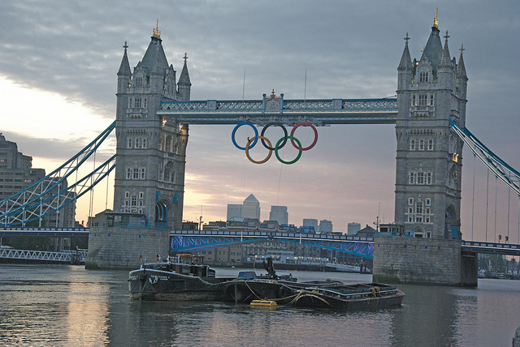
Lewis House, Peach Court and Millennium House
As you are not tenants of WFHA your arrangements will be slightly different. As above, if WFHA are required, we will do our best to attend. We will also ensure that your landlord provides information to you on any changes to your services during the period, and that they display this information on notice boards at your schemes.

A busy borough, with lots of visitors ….
WFHA really hope that all our tenants are able to enjoy the games. It is very exciting for Londoners, even if you are just watching it on the television. However, we do want people to be mindful that there will be LOTS of visitors to the area. Along with genuine tourists there may be a small amount of people who are “up to no good”. If you are out and about and are approached by people offering you tickets, merchandise, or who are looking for accommodation, please do not engage with them and report their activities to the Police.

